Travelling Salesman Problem
AIM:
To write a Python program to find the shortest possible route that visits every city once and returns to the starting city.

ALGORITHMS:
- Start.
- Read the cities and the distance between each pair of cities.
- Select a starting city.
- Generate all possible routes through the remaining cities.
- Calculate the total distance of each route, including the return to the starting city.
- Compare the distances of all routes.
- Select the route with the minimum total distance.
- Display the shortest route and its total cost.
- Stop.

CODE:
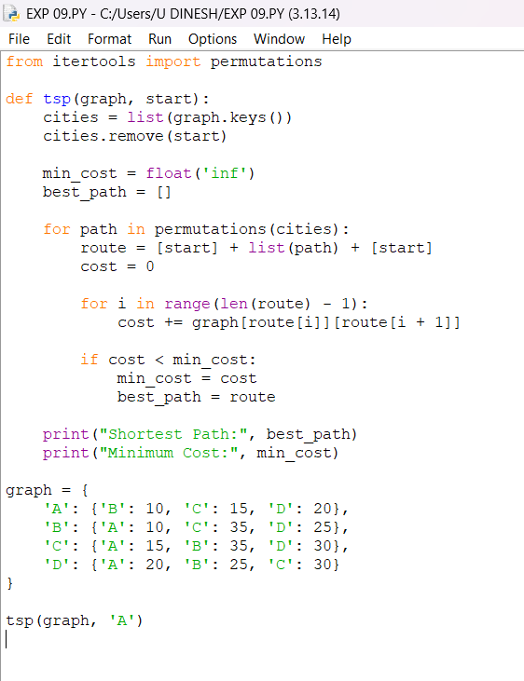
OUTPUT:
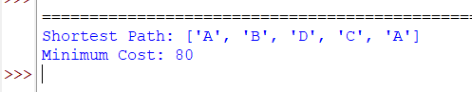
RESULT:
Travelling Salesman Problem: The shortest possible tour visiting every city once and returning to the starting city is found.

